MED D - Test Claim

High Level Process
Process
Related Documents

Description: This is used for Test Claim calls about price quotes inquiries.

High Level Process
- Determine the appropriate Test Claim to run.  - If manual, proceed to next step.  - If Existing Claim, proceed to Populate Test Claim from Existing Entry.  - If pharmacist calling to process inactive NDC, refer to Inactive NDC. | Reminders:  - Do NOT run a test claim for vaccines unless pharmacy coverage is indicated in the CIF for the vaccine.
- Verify the Drug Name, Strength, Day Supply and the name of the retail pharmacy that the beneficiary will be using.
- Complete the following fields under Selection Criteria.  - Delivery Systems  - May Sub  - Drug Label  - Quantity  - Day Supply  - NPI/NCPDP | Reminders:  - For information on Test Claims for Specialty Medications, refer to Specialty Pharmacy (CTS - Therapeutic Pharmacy Services).  - If attempting to process a Test Claim for a Third Party Adjudicated (TPA) client, the following message displays, Test Claim not available for externally adjudicated clients. Refer to Third Party Adjudicated Client (TPA) for more information.  - For Ointments, educate the beneficiary that their prescriber should indicate the size and quantity of the tube/bottle we are to dispense. Use this information to run the test claim for the appropriate package size and quantity.  - For Grains, transfer Clinical Care Services to obtain the correct quantity.  - For durable equipment, review the CIF and call Clinical to get the NDC number to perform a Test Claim for drug coverage if available.
- Review the Test Claim results for each Test Claim in the table.  - If accepted, communicate the results.  - If denied, Do Not quote pricing for Denied claims and proceed to next step. | Reminders:  - Read Disclaimers in PeopleSafe to beneficiary  - Do NOT provide pricing for Denied claims.  - Do NOT use the Find a Drug screen from the Tools drop-down menu to locate a formulary alternative. If the beneficiary is requesting alternatives, refer to MED D - CCR - Coverage Determinations and Redeterminations (Appeals).

Top of the Document

Process

Perform the steps below:
Step | Action
1 | Determine the appropriate Test Claim to run.  - If manual, proceed to next step.  - If existing claim, refer to Populate Test Claim from Existing Entry.  - If pharmacist calling to process inactive NDC, refer to Inactive NDC.  Return to High Level Process
2 | Verify the Drug Name, Strength, Day Supply and the name of the retail pharmacy that the beneficiary will be using.  - The drug name, strength and Days’ Supply is…  - Thank you, what retail pharmacy will you be using to fill this medication?  Return to High Level Process
3 | Select Test Claim, if the Test Claim screen does not automatically populate  Note: If the Test Claim screen displays the message Maintenance Choice Program Available, consult with the beneficiary on the available Maintenance Choice options and benefits if appropriate. Review the CIF and Client Program offerings in PeopleSafe.  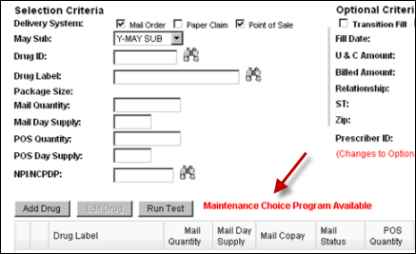  Return to High Level Process
3 | Field… |  | Description…
3 | Delivery System |  | Identifies how the medication is being dispensed, by Mail Order/Point of Sale (retail).
3 | May Sub |  | DAW - Dispensed as written is how the Dr. has written the prescription)
3 | Drug ID |  | Enables search for the medication using the NDC number.
3 | Drug Label |  | Enables search for the medication using the full name of the medication or the first 3 letters.
3 | Package Size |  | Identifies the size of the package that is prescribed.
3 | Mail Quantity |  | The prescribed amount for Mail Order. Filled in when Delivery System = Mail.
3 | Mail Day Supply |  | The number of days prescribed for Mail Order. Filled in when Delivery System = Mail.
3 | POS Quantity |  | The amount prescribed for retail. Filled in when Delivery System = POS
3 | POS Day Supply |  | The number of days prescribed for retail. Filled in when Delivery System = POS
3 | NPI/NCPDP |  | The national provider identification of the local pharmacy.
4 | Select all applicable delivery systems.  Best Practice: A Test Claim should be processed for Mail Order and Point of Sale at the same time if the client has both mail and retail benefits by selecting both of these checkboxes when applicable.  Return to High Level Process
5 | Choose the correct option in the May Sub box.  For Test Claims: (Mail Order or Retail)  - Did the doctor write the prescription:  - As brand only, select MD-NO  - Generics permitted, if yes select Y-MAY SUB  Note: If beneficiary is requesting Brand only, choose PATIENT-NO.  Selecting the incorrect option from the MAY-SUB dropdown menu can cause incorrect Test Claim results, as some plans have penalties based on DAW rules.  Notes:  - DO NOT use BOTH–NO. The plan may have a DAW Penalty depending on who is requesting brand.  - If the wrong May Sub option is selected a DAW Penalty may apply. Refer to DAW and RBP Penalties Job Aid.  - Prescriptions are filled as written; if generic or name brand are preferred, the beneficiary will need to communicate with the physician.  - Some of the generic medications listed are not A/B Rated, but show up as an alternative.  - Some plans have an automatic generic substitution on all medications unless specified by the beneficiary or the prescriber. Run Test Claims on physician DAW and patient DAW to see if there are any cost differences.  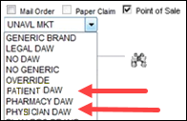  Return to High Level Process
6 | - Enter the name of the medication in the Drug Label field.  Tips:  - When using an NDC to locate the medication, vaccine, or supplies for the beneficiary enter the NDC # into the Drug ID field of the test claim screen, then click on the binoculars, which populates the medication.  - An alternative way to find the same information is starting on the Test Claim screen, select the binoculars adjacent to the drug label box and enter the NDC into the Drug ID field on this screen. Select the appropriate radial box is selected and continue with test claim.  - Search for the medication using the first three letters of the name in the Drug Label field.  - Press the tab button or select the binoculars to search and display the Find a Drug screen.  Result: System provides a list of most commonly dispensed NDC numbers for the medication. If the NDC is no longer active refer to Inactive NDC.  Tips:  - Repackaged NDC’s will not display because they are not the most commonly used. If the drug and drug strength does not display, click on Search All button.  - For prescriptions with abbreviations, place a space between each letter when searching.  Example: BD Pen needles, use B D to search for better results.  - Select radio button of the correct drug and strength.  Result: Generics are indicated with asterisks * only if you have Mail Order selected in the check boxes on the Find a Drug screen.  Example: 1mcg (microgram) = 0.001mg. Displays as Synthroid 125mcg is equivalent to Synthroid 0.125mg.  Return to High Level Process
7 | Click the Select button to return to the Test Claim screen.  - If a name brand is selected when there is a generic available, a pop up box displays.  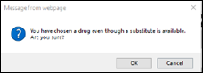  - Leaving this as Y for May Sub may give incorrect pricing as DAW penalties may apply.  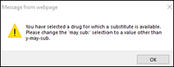  Notes:  - If a Controlled Substance is selected, a pop-up displays. The message states that it is a Controlled Substance and provides the DEA class of the medication (C1 - C5). If this message is received, access the Controlled Substance State Laws for mail service prescriptions to verify if any state restrictions will apply to the medication.  - A retail version of the Controlled Substance State Laws Reference Table is not available. It is up to the Retail Pharmacy to determine if they will fill the prescription.  Return to High Level Process
8 | Enter the correct Quantity and Day Supply amounts for Mail Order and/or Point of Sale.  Refer to  - MED D - Test Claim Index  - Calculating Quantities for Packaged Medication  Notes:  If at any time you are unsure of the quantity needed, transfer to Clinical Care Services Clinical Counseling Team. Refer to MED D - When to Transfer Calls to Clinical Care Services Clinical Counseling.  - For prescriptions written for quantity in a given time frame, follow directions below:  Example: Take 1 tablet every 4-6 hours, use the lower number of hours to calculate the maximum possible dosage.  Note: 4 hours would be used not 6 and would equal 6 pills per day. This is no guarantee the beneficiary will receive this quantity, but it will provide them with the maximum estimated cost for the prescription.  Return to High Level Process
9 | Enter the NPI/NCPDP number:  - Select the binoculars.  - Select the radio button of the appropriate pharmacy.  - Click on Select.  Note: If this is a Retail 90 client, refer to Retail Pharmacy Locator.  Notes:  - If the Test Claim screen displays the message, Preferred Pharmacy available consult with the beneficiary on the available Preferred Pharmacy options and benefits if appropriate. Refer to Retail Pharmacy Locator.  - For Specialty Test Claims, enter the NCPDP / NPI number of the specialty pharmacy used by the customer. Offer to conduct a test claim from a Specialty pharmacy of their choice to compare to one of the identified specialty pharmacies listed below for the lowest cost.  - Caremark Specialty Pharmacy: 1134100134  - Kroger Specialty Pharmacy: 1598765570  - Walmart Pharmacy: 1013934413  Note: The three pharmacies listed above are a subset of Specialty pharmacies available in the network and the beneficiary is always free to choose any in-network pharmacy of their choice.  Return to High Level Process
10 | - Click Run Test button.  - If test claim requires editing, proceed to Edit a Test Claim.  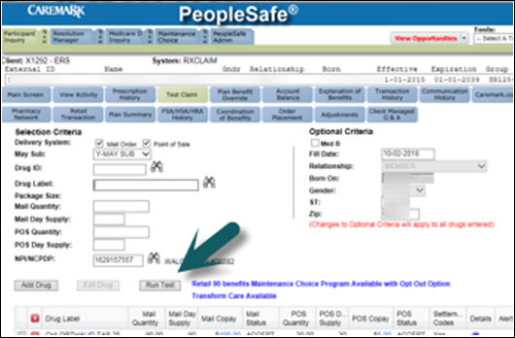  Note: After 3 drugs have been entered, the Add Drug button will be disabled. If the beneficiary requires more than 3 Test Claims:  - Run tests for the first 3 drugs; then remove one or more of the Test Claim results by clicking the next to the line item. This allows addition of drugs to the table. Another option is to click the Clear button at the bottom right but use caution as this will remove all drugs from the list.  - Since Test Claim information is not permanently recorded, provide the beneficiary with the claim information after each test is run.  Return to High Level Process
11 | Click on the icon in the Details column to review the Test Claim results for each Test Claim in the table.  - Copay  - STCOB (amount the secondary plan will pay)  - Status conflict  - Settlement code  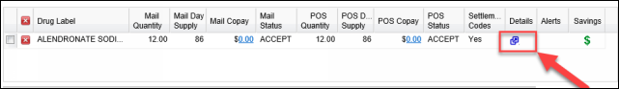  Refer to the following if appropriate:  - The CCR Checklist within MED D - CCR - Coverage Determinations and Redeterminations (Appeals)  Note:  - If the beneficiary is requesting alternatives, refer to MED D - CCR - Coverage Determinations and Redeterminations (Appeals).  - If it is an EGWP plan, review Supplemental Financials. Refer to MED D - Single Transaction Coordination of Benefits (STCOB) Tips and Reminders.  Return to High Level Process
11 | If… | Then…
11 | Accepted | Communicate the results  - Read the disclaimer.  Please note the prices quoted are estimates and may not reflect your actual out of pocket costs.  - Provide the co-payment amount.  - Explain the following to the beneficiary:  They may have a higher co-payment for a non-generic / non-formulary medication. The claim may not process due to your state law restrictions. If beneficiary had questions about their state laws, they would need to discuss with their local pharmacist.  Note: The Formulary, also called Drug List, is a list of covered drugs selected by the Plan in consultation with a team of healthcare providers. The formulary represents the prescription therapies believed to be a necessary part of a quality treatment program. The list must meet requirements set by Medicare. Medicare has approved the Plan’s Drug List. The Plan offers a broad selection of medications while keeping plan costs controlled for beneficiaries. All considerations were made based on the Food and Drug Administration (FDA)-approved recommendations, clinical studies and manufacturer guidelines. The Plan will generally cover the drugs listed in the formulary as long as the drug is medically necessary, the prescription is filled at a plan network pharmacy, and other plan rules, as described in the Evidence of Coverage (EOC) are followed.  Note: There is no accruing of Accumulations for the Test Claim results.  - Even though more than one Test Claim can be processed at a time, the results only reflect the individual claim. This means that any deductible, MAB or MOOP accumulator will be factored into each individual Test Claim.  - If the beneficiary has an accumulator, such as a deductible that has not been met, advise them that each quote includes the deductible; however, the beneficiary will only have to meet the deductible once.
11 | Denied | Do Not quote pricing for Denied claims.  I apologize but I am unable to provide a quote for <medication name> at this time.

Top of the Document

Related Documents
MED D - Test Claim Index
MED D - Explaining and Calculating Claims Example 1
MED D - Explaining and Calculating Claims Example 2

Parent SOP: CALL-0048: Medicare Part D Customer Care Call Center Requirements-CVS Caremark Part D Services, L.L.C.
Abbreviations/Definitions: Abbreviations / Definitions
Top of the Document

Not to Be Reproduced or Disclosed to Others without Prior Written Approval
ELECTRONIC DATA = OFFICIAL VERSION – PAPER COPY = INFORMATIONAL ONLY

